Question 1 (7 marks)

<EFOFEX>
id:fxd{1b428f73-566e-4ed3-908f-f6575d3bdec4}

FXData:
</EFOFEX>The diagram shows the complex  
numbers and in the Argand plane.

(a) Express in

(i) polar form. (1 mark)

(ii) Cartesian form. (1 mark)

(b) Plot and label the following complex numbers on the diagram above:

(i) . (1 mark)

(ii) . (2 marks)

(iii) . (2 marks)

Question 1 (7 marks)

<EFOFEX>
id:fxd{b9badcc3-f126-461e-ab6c-9c3c3c150b84}

FXData:
</EFOFEX>The diagram shows the complex  
numbers and in the Argand plane.

(a) Express in

|  |
| --- |
| Solution |
|  |
| Specific behaviours |
| ✓ correct expression |

(i) polar form. (1 mark)

(ii) Cartesian form. (1 mark)

|  |
| --- |
| Solution |
|  |
| Specific behaviours |
| ✓ correct expression |

(b) Plot and label the following complex numbers on the diagram above:

|  |
| --- |
| Solution |
| Rotates by about . |
| Specific behaviours |
| ✓ plots correctly |

(i) . (1 mark)

|  |
| --- |
| Solution |
|  |
| Specific behaviours |
| ✓ correct argument  ü correct modulus |

(ii) . (2 marks)

|  |
| --- |
| Solution |
| Use vector addition of and , so that |
| Specific behaviours |
| ✓ correct argument  ü correct modulus |

(iii) . (2 marks)

Question 6 (7 marks)

(a) Given that , determine the modulus and argument of . (3 marks)

(b) Sketch the subset of the complex plane determined by . (4 marks)

<EFOFEX>
id:fxd{351273e5-6e08-4ac0-a7a8-07727fdf31e9}

FXData:

</EFOFEX>

Question 6 (7 marks)

(a) Given that , determine the modulus and argument of . (3 marks)

|  |
| --- |
| Solution |
|  |
| Specific behaviours |
| ✓ expresses numerator and denominator in polar form  ü modulus  ü argument |

(b) Sketch the subset of the complex plane determined by . (4 marks)

<EFOFEX>
id:fxd{b69893a7-a478-4f32-acd4-1981b10deda1}

FXData:

</EFOFEX>

|  |
| --- |
| Solution |
| Let so that |
| Specific behaviours |
| ✓ uses Cartesian form to eliminate  ü obtains relationship  ü sketches parabolic curve  ü correct vertex and other intercepts |

Question 1 (6 marks)

The polynomial , where .

(a) Show that is a factor of . (2 marks)

(b) Given that , solve , giving all solutions in Cartesian form. (4 marks)

Question 1 (6 marks)

The polynomial , where .

(a) Show that is a factor of . (2 marks)

|  |
| --- |
| Solution |
|  |
| Specific behaviours |
| ✓ substitutes  ü fully expands all terms and then simplifies |

(b) Given that , solve , giving all solutions in Cartesian form. (4 marks)

|  |
| --- |
| Solution |
| Since is a factor of then and its conjugate will both be solutions.  Comparing coefficients, .  Hence when . |
| Specific behaviours |
| ✓ uses result from part (a) to state two solutions  ü determines  ü one correct solution to  ü states all correct solutions |

Question 2 (5 marks)

(a) Express the complex number in the form . (3 marks)

(b) When and determine

(i) . (1 mark)

(ii) . (1 mark)

Question 2 (5 marks)

(a) Express the complex number in the form . (3 marks)

|  |
| --- |
| Solution |
|  |
| Specific behaviours |
| ✓ exposes real and imaginary parts  ü correct modulus  ü correct answer in polar form |

(b) When and determine

|  |
| --- |
| Solution |
|  |
| Specific behaviours |
| ✓ correct value |

(i) . (1 mark)

(ii) . (1 mark)

|  |
| --- |
| Solution |
|  |
| Specific behaviours |
| ✓ correct value |

Question 5 (7 marks)

Consider the complex number .

(a) On the Argand diagram below, draw a line segment from the origin to and from the origin to . (2 marks)

<EFOFEX>
id:fxd{348df4ff-e461-43c4-96a1-37ae900544d6}

FXData:

</EFOFEX>

(b) Determine the principal value of the argument of . (3 marks)

(c) Determine the value of the modulus of . (2 marks)

Question 5 (7 marks)

Consider the complex number .

(a) On the Argand diagram below, draw a line segment from the origin to and from the origin to . (2 marks)

<EFOFEX>
id:fxd{eae87b03-67be-44b2-98d1-1c0729037832}

FXData:

</EFOFEX>

|  |
| --- |
| Solution |
| See diagram |
| Specific behaviours |
| ✓ line to  ü line to |

(b) Determine the principal value of the argument of . (3 marks)

|  |
| --- |
| Solution |
| . Using properties of rhombus, the line from to bisects angle between axis and line from to :  Hence . |
| Specific behaviours |
| ✓ indicates polar form of  ü uses properties of rhombus  ü correct value |

(c) Determine the value of the modulus of . (2 marks)

|  |
| --- |
| Solution |
|  |
| Specific behaviours |
| ✓ indicates lengths of suitable right triangle  ü correct value, with some simplification |

Question 6 (7 marks)

Let the complex number . Describe geometrically the locus of the complex number in the Argand plane that is determined by the relation .

Question 6 (7 marks)

Let the complex number . Describe geometrically the locus of the complex number in the Argand plane that is determined by the relation .

|  |
| --- |
| Solution |
| Hence the locus of is a circle of radius units with centre at . |
| Specific behaviours |
| ü in Cartesian form  ü in Cartesian form  ü uses and modulus to eliminate  ü expands and simplifies equation  ü factors squared terms  ü describes locus as a circle  ü states correct centre and radius of circle |

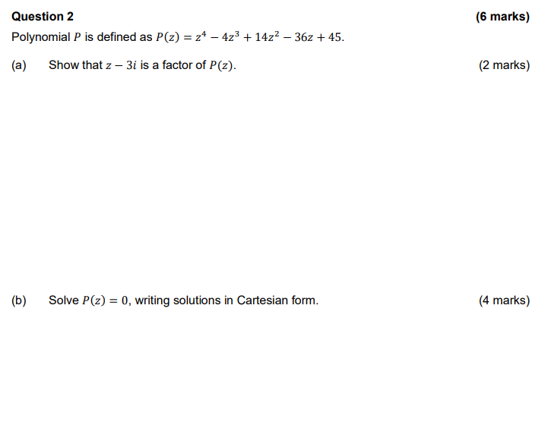

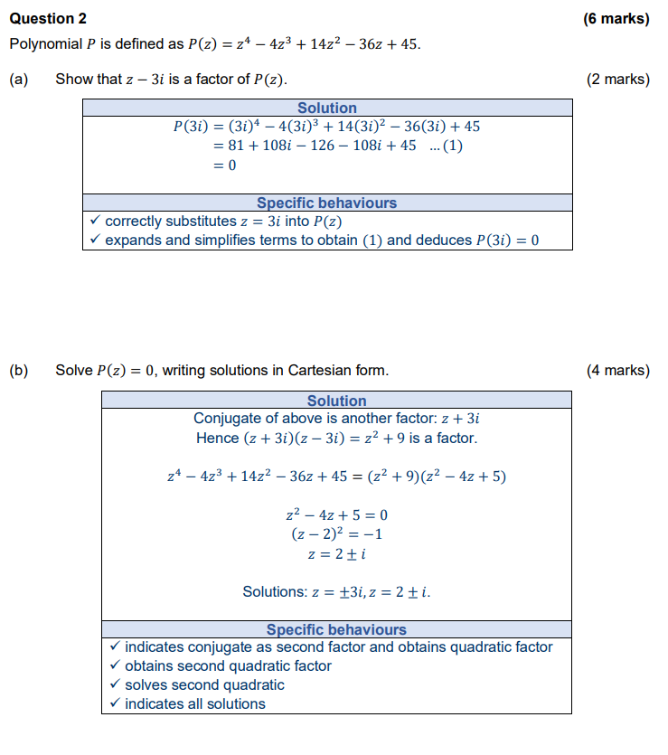

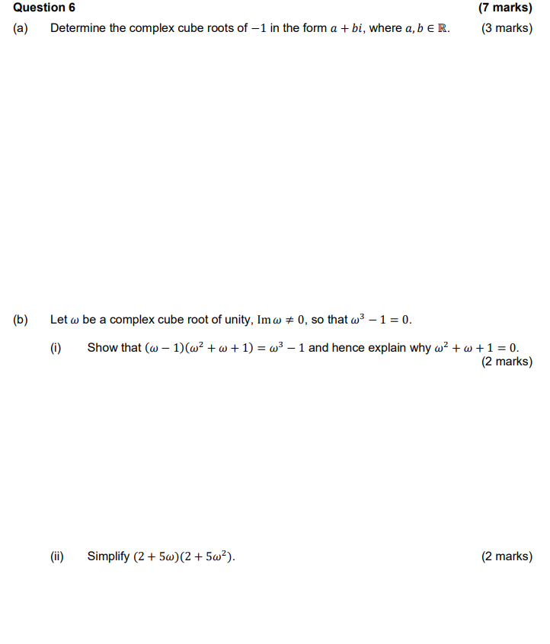

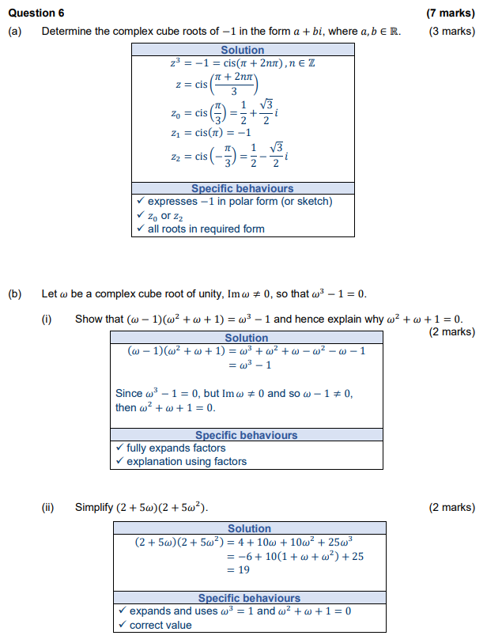

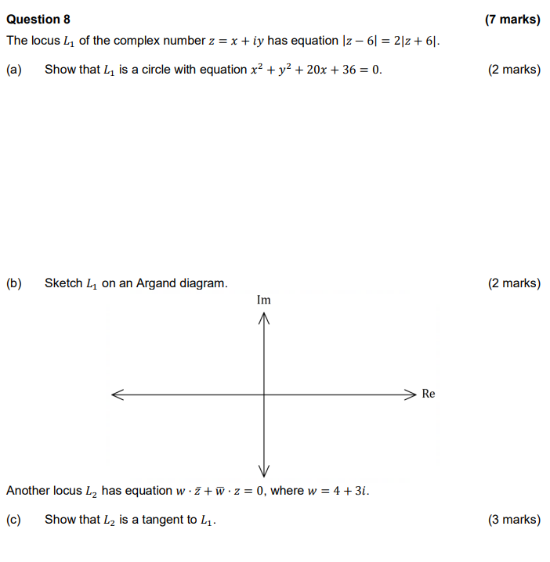

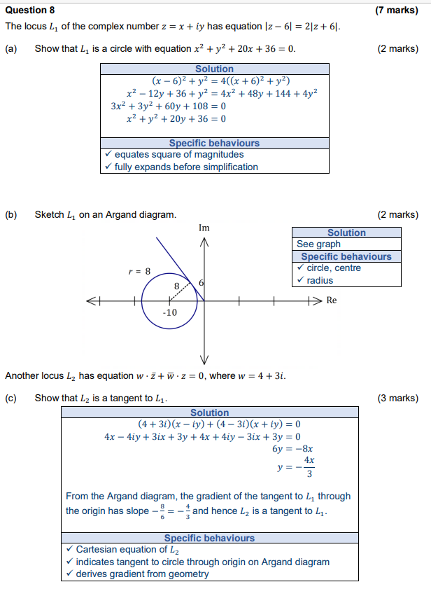

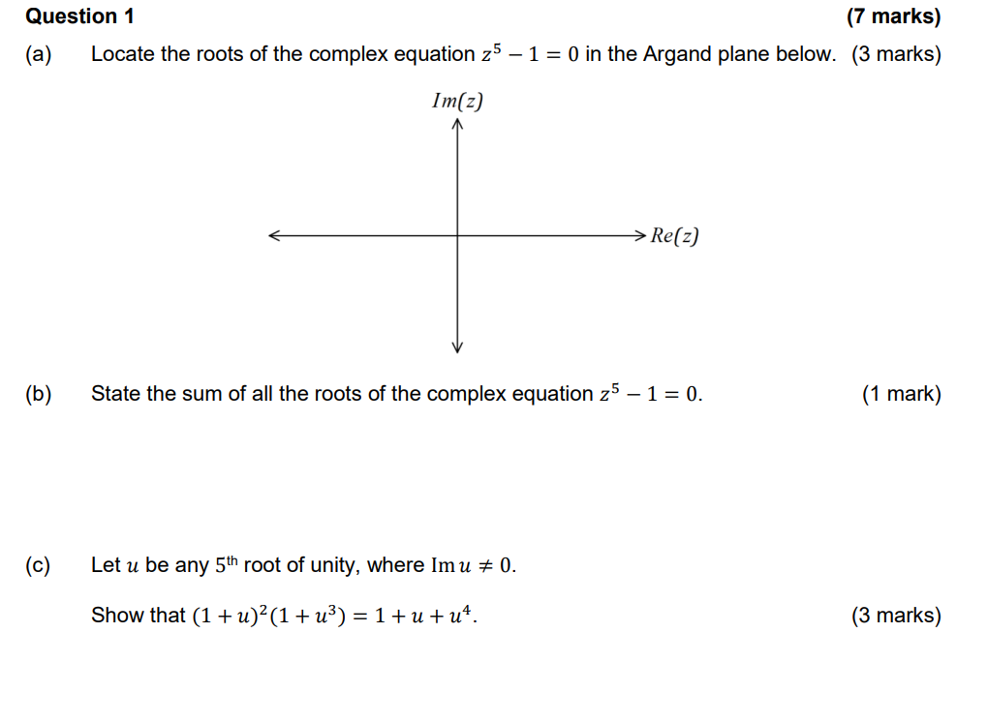

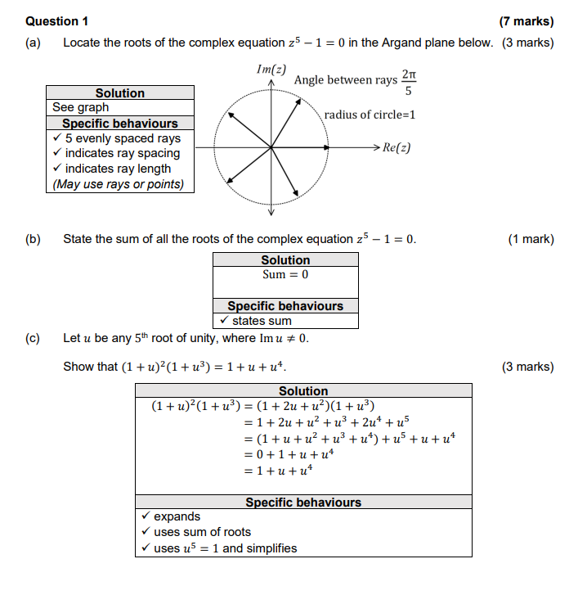

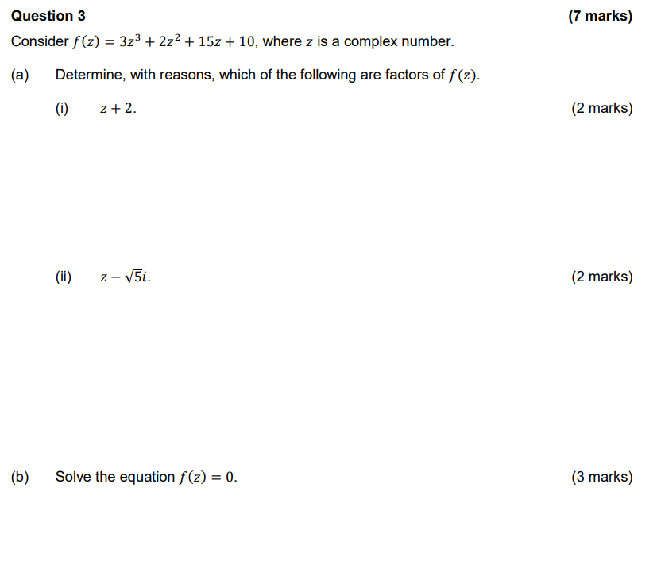  
  
  
  
  
  
  
  
  
  
  
  
  
  
  
  
  
  
  
  
  
  
  
  
  
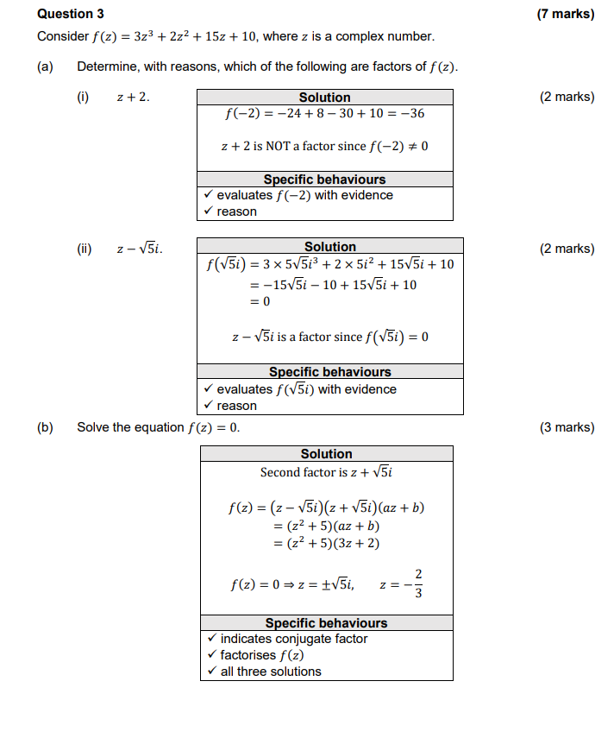

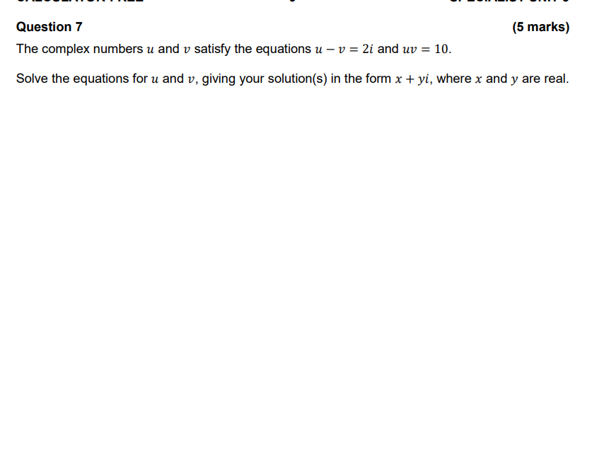

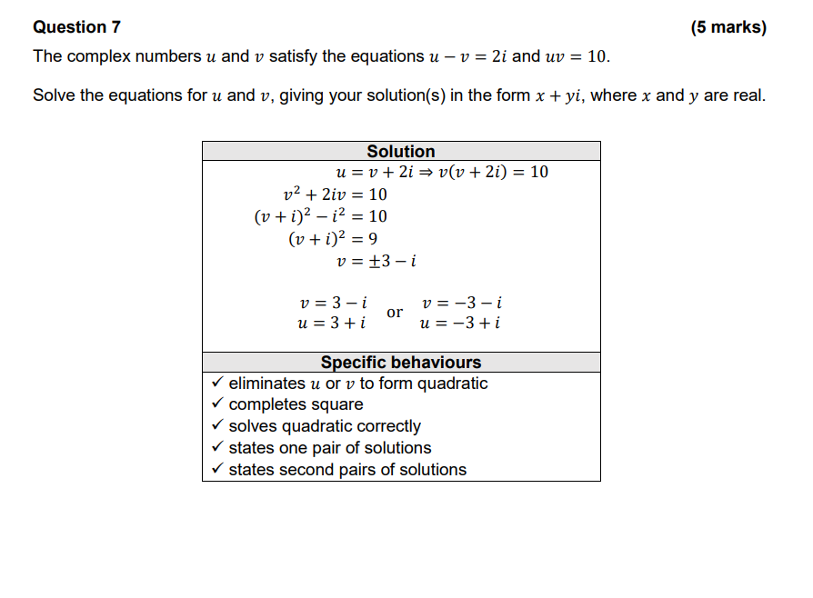

Question 3 (8 marks)

(a) Let .

(i) Express z in Cartesian form. (2 marks)

(ii) Determine  in Cartesian form. (3 marks)

(b) If , sketch the location of all roots of this equation on the axes below.

(3 marks)

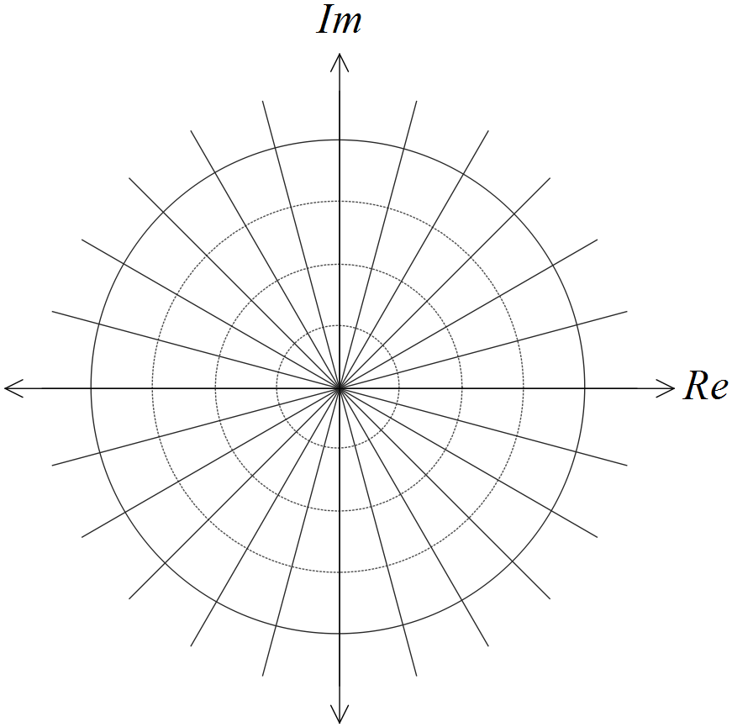

Question 3 (8 marks)

(a) Let .

(i) Express z in Cartesian form. (2 marks)

|  |
| --- |
| **Solution** |
|  |
| **Specific behaviours** |
| ✓ real part  ✓ imaginary part |

(ii) Determine  in Cartesian form. (3 marks)

|  |
| --- |
| **Solution** |
|  |
| **Specific behaviours** |
| ✓ uses polar form to determine modulus  ✓ uses polar form to determine argument  ✓ converts to Cartesian form |

(b) If , sketch the location of all roots of this equation on the axes below.

(3 marks)

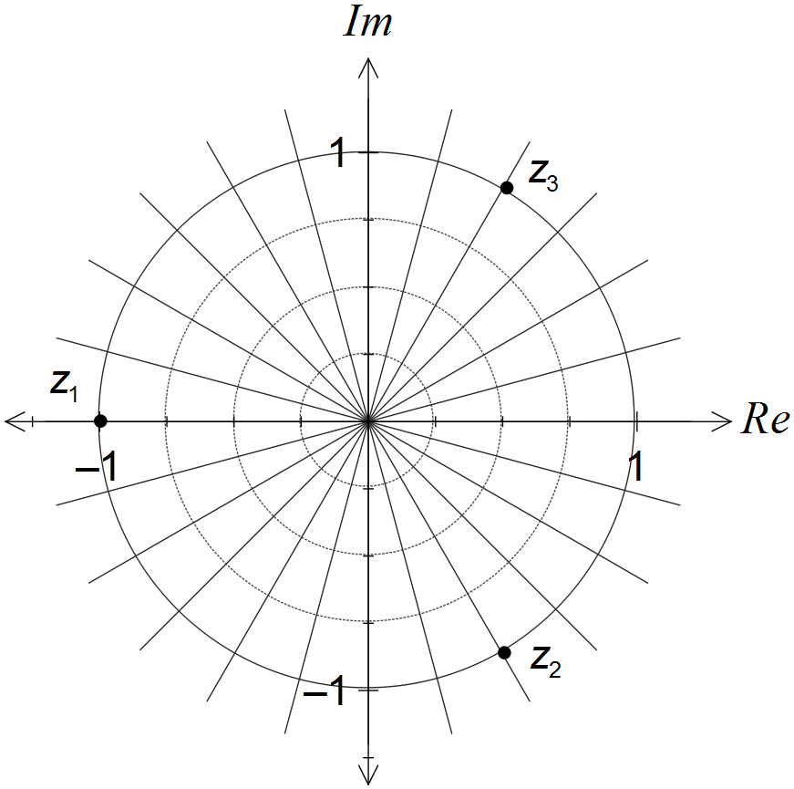

|  |
| --- |
| **Solution** |
| See diagram - evenly spaced points on circle |
| **Specific behaviours** |
| ✓ Adds scale to show real root at -1  ✓ Shows second root third way around circle  ✓ Shows third root as conjugate of second |

Question 5 (7 marks)

Consider the function .

(a) Determine the remainder when is divided by . (1 mark)

(b) Show that is a factor of . (2 marks)

(c) Solve . (4 marks)

Question 5 (7 marks)

Consider the function .

(a) Determine the remainder when is divided by . (1 mark)

|  |
| --- |
| Solution |
|  |
| Specific behaviours |
| ü correct remainder |

(b) Show that is a factor of . (2 marks)

|  |
| --- |
| Solution |
|  |
| Specific behaviours |
| ✓ correctly evaluates powers of  ü simplifies to show line that clearly sums to zero |

(c) Solve . (4 marks)

|  |
| --- |
| Solution |
| Since is a factor then must also be a factor.  Hence when . |
| Specific behaviours |
| ✓ uses complex conjugate to obtain one quadratic factor of  ü determines second quadratic factor  ü shows use of appropriate method to solve  ü states all solutions |